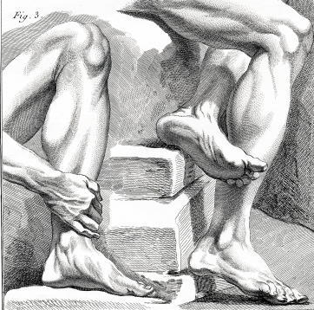

2021 Annual Foot and Ankle Scientific Seminar Poster Exhibits Guidelines

If you would like your research to be considered for presentation at the 2021 Annual Ohio Foot and Ankle Scientific Seminar email your poster information by March 12, 2021. Your application and abstract may be submitted to OFAMF via email to lridolfo@ohfama.org. Remember, not all submissions are accepted.
Submission Deadline: March 12, 2021
Notification regarding acceptance of posters will be e-mailed by May 18, 2021
Finalist will be asked to do a brief five minute presentation on Thursday June 10, 2021 after the Scientific Paper Competition at the Columbus Hilton at Easton during the 2021 Annual Foot and Ankle Scientific Seminar.
IMPORTANT! Before you begin your submission, carefully review the below information.
POSTER SUBMISSIONS
Poster abstracts must be submitted via email to OFAMF before March 12, 2021. Late submissions will not be accepted.
• Posters must be original research, not previously published.

• Correspondence will ONLY be sent to the correspondent author (the person identified in the submission as the correspondent author); it is the correspondent author’s responsibility to communicate all information to their poster team.

• Seminar Registration—At least one of the poster authors must register for and attend the Annual Seminar in order for their poster to be displayed.

• All posters accepted for presentation at the 2021 Annual Ohio Foot and Ankle Scientific Seminar must be submitted in PDF format AND a poster must also be brought to the annual conference for display and be professionally mounted on foam board for mounting.
Posters are a maximum of 3.5 feet high x 7.5 feet wide and will be displayed at the Annual Seminar for 2 days,
June 10 & 11, 2021. Poster must be provided and be professionally mounted on foam board for mounting.
• Only completed studies will be accepted for presentation.

• Commercial terminology (company/product name) is discouraged; use generic terminology whenever possible. Use of commercial terminology may result in your poster being disqualified.

• Mandatory Financial Disclosure
Conflict of Interest/FDA Relationship Disclosure is required of all authors of a poster abstract/exhibit. If a poster submission is accepted, the FDA disclosure(s) of all authors will be indicated in the Annual Scientific Conference final program.
• Posters will ONLY be accepted in one of the following classifications:
7 - Peripheral Nerve Disorders
8 - Physical Therapy/Rehabilitation
9 - Rearfoot and Ankle Reconstruction
10 - Trauma (Surgical/Conservative)
11 - Wound Care/Infectious Diseases

1 - Arthroscopy
2 - Biomechanics and Anatomy
3 - Diabetic Foot
4 - Forefoot Reconstruction
5 - Heel Pain
6 - Orthotics/Prosthetics/Pedorthics
The “Level of Evidence” must be included in the online submission for your abstract to be considered for presentation. (See Page 3)
• Poster submissions are required to have a minimum follow-up of 10 months prior to submission; follow-up time must be included in the online submission for your abstract to be considered for presentation.

• Submitted abstracts will be reviewed to determine if the poster meets standards for presentation. Not all submissions are accepted. Accepted abstracts are part of the judging process for the poster competition.

• Once a poster abstract is submitted:
- Poster titles cannot be changed.
- Additional authors cannot be added and author names cannot be changed
• The title of your poster will appear in the program exactly as you enter it in the online submission.

Helpful Hints:
• Determine the lead/primary author before submission.
• Select the correct level of evidence for the case or scientific study. Is your study randomized, double blinded or a case series?
• Use appropriate statistical analysis if warranted.
• Number references consecutively in the order of their first use in the text (not alphabetically).
• Make sure pictures and graphs are legible and engaging.
• Keep captions and all posted written material to a minimum.
• Make sure to use appropriate color combinations. For instance, do not use yellow or red on a blue background.
• Attach poster exhibits to the board with pushpins or thumbtacks. Bring your own pushpins/thumbtacks.
• Handout material may be provided by the author(s).

Disclaimer:
The OFAMF does not endorse any procedures/treatments represented in the posters displayed in the Annual Foot and Ankle Scientific Seminar Poster Exhibit.
INSTRUCTIONS FOR SUBMITTING YOUR POSTER ABSTRACT
1. Before you begin your submission, determine the correct format (Case Study or Scientific) for your study.

FORMAT DEFINITIONS
• Case Study format refers to the collection and presentation of detailed information about a particular participant or small group, frequently including the accounts of subjects themselves. A form of qualitative descriptive research, the case study looks intensely at an individual or small participant pool, drawing conclusions only about that participant or group and only in that specific context. Researchers do not focus on the discovery of a universal, generalizable truth, nor do they typically look for cause-effect relationships; instead, emphasis is placed on exploration and description.

A case series is a group of case reports. It is preferred to use the scientific format in this situation if a conclusion about the subject is made by the author(s).
• Scientific format refers to the study/evaluation of a question and formation of a hypothesis and the development of methodology directed to addressing the hypothesis; it could be prospective or retrospective. It involves gathering information, testing the hypothesis, interpretation of the data and drawing conclusions that validate or negate the hypothesis. Meta-analysis research will be accepted; however, systematic review alone does not qualify. Literature Reviews are NOT accepted.
2. Submit your application to Luci Ridolfo, OFAMF Executive Director via email at lridolfo@ohfama.org

3. Include all of the below information in the email submission:

• Title: Type the title of your poster abstract exactly as you would like it to be published (Upper/Lower Case, please). The title should be brief and clearly indicate the nature of the study.

• Author Name(s): In the spaces provided, list full names of authors and their medical degree/designation.
• Abstract: You must complete all sections; failure to do so will disqualify your submission. Maximum 250 words including the following:

o Statement of Purpose: Statement that explains what you want to investigate and the rationale behind your choice of study.
o Methodology: Methodology consists of a brief description of the target sample, including sample size and demographics if relevant, as well as the general design of the study (retrospective chart review, experimental design, survey-based design, qualitative research, etc.) and statistical analysis. (For a case-study, enter literature review in this section.)
o Procedures (For a case-study, summarize the case in this section.)
o Results: Results must be clearly presented and summarized.
o Discussion: Must be based on the study results and integrated with the statement of Purpose, and the literature review.
o Level of evidence: See chart below.

• Abbreviations may be used (Index Medicus). Please spell out the terminology, followed by the abbreviation in parentheses. Thereafter, abbreviations only may be used.

3 Levels of Evidence for Primary Research Question
Therapeutic Studies--  Investigating the Results of  Treatment  Types of Studies |  | Prognostic Studies--  Investigating the Effect of a  Patient Characteristic on the  Outcome of Disease |  |  | Diagnostic Studies--  Investigating a Diagnostic Test | Economic and  Decision Analyses--  Developing an  Economic or Decision  Model
Level 1 | • High-quality randomized controlled trial with statistically significant difference or no statistically significant difference but narrow confidence intervals  • Systematic review² of Level-1 randomized controlled trials (studies were homogeneous) |  | • High-quality prospective study4 (all patients were enrolled at the same point in their disease with≥80% follow-up of enrolled patients)  • Systematic review² of Level-1 studies | • Testing of previously developed diagnostic criteria in series of consecutive patients (with universally applied reference “gold” standard)  • Systematic review² of Level-1 studies |  |  | • Sensible costs and alternatives; values obtained from many studies; multiway sensitivity analyses  • Systematic review² of Level-1 studies
Level 2 | • Lesser-quality randomized controlled trial (e.g. <80% follow-up, no blinding, or improper randomization)  • Prospective4 comparative study5  • Systematic review² of Level-2 studies or Level-1 studies with inconsistent results |  | • Retrospective6 study  • Untreated controls from a randomized controlled trial  • Lesser-quality prospective study (e.g., patients enrolled at different points in their disease or <80% follow-up)  • Systematic review² of Level-2 studies | • Development of diagnostic criteria on basis of consecutive patients (with universally applied reference “gold” standard)  • Systematic review² of Level-2 studies |  |  | • Sensible costs and alternatives; values obtained from limited studies; multiway sensitivity analyses  • Systematic review² of Level-2 studies
Level 3 | • Case-control study7  • Retrospective6 comparative study5  • Systematic review² of Level-3 studies |  | • Case-control study7 | • Study of nonconsecutive patients (without consistently applied reference “gold” standard)  • Systematic review² of Level-3 studies |  |  | • Analyses based on limited alternatives and costs; poor estimates  • Systematic review² of Level-3 studies
Level 4 | Case series8 |  | Case series | • Case-control study  • Poor reference standard |  |  | • No sensitivity analyses
Level 5 | Expert opinion |  | Expert opinion | Expert opinion |  |  | Expert opinion
1. A complete assessment of the quality of individual studies requires critical appraisal of all aspects of the study design.
2. A combination of results from two or more prior studies.
3. Studies provided consistent results.
4. Study was started before the first patient enrolled.
5. Patients treated one way (e.g., with arthrodesis) compared with patients treated another way (e.g., with arthroplasty) at the same institution.
6. Study was started after the first patient enrolled.
7. Patients identified for the study on the basis of their outcome (e.g., failed arthrodesis), called “cases”, are compared with those who did not have the outcome (e.g., had a successful arthrodesis), called “controls”.
8. Patients treated one way with no comparison group of patients treated another way.

This chart was adapted from material published by the Centre for Evidence-Based Medicine, Oxford, UK. For more information, please see www.cebm.net. 4/09
Example of Poster – Case Study Format
Title, Statement of Purpose, Case Study, Case Study, Analysis & Discussion, Analysis & Literature Review, References.
Please remember, that the overall visual appearance will be assessed by the judges. Position each section sequentially beginning with the Purpose, Literature Review, Case Study, Analysis and Discussion, and References (references should be noted numerically in the order used in text). Use generic names whenever possible instead of proprietary/commercial names. Maximum poster size: 3.5 feet high x 7.5 feet wide.

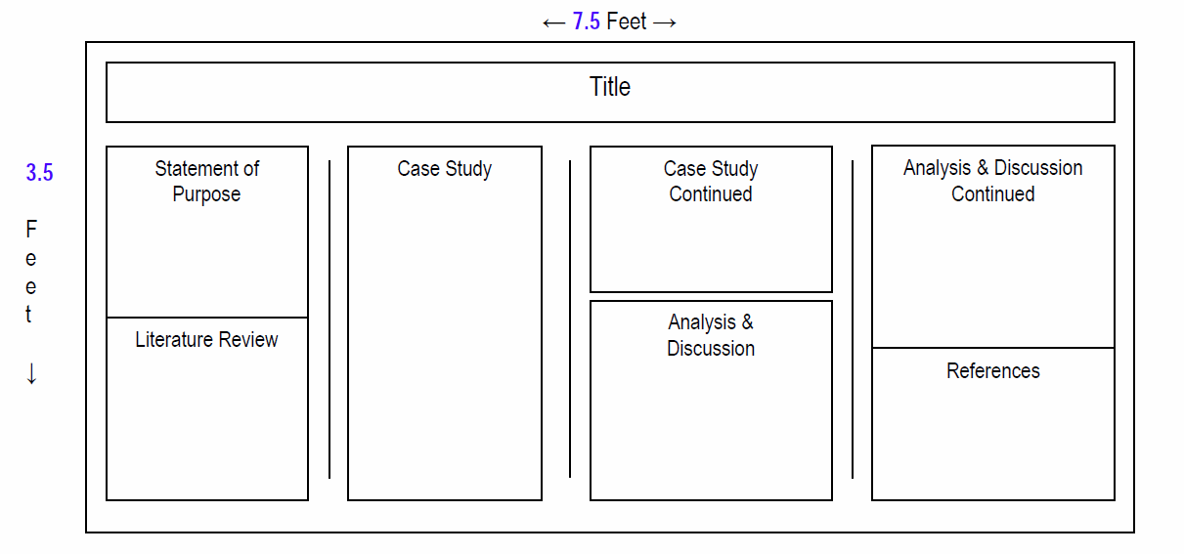

Key questions Poster Judges will consider:
Case Study Posters
1. Title (+1 point)
How well does the title capture the essence of the poster?
2. Statement of Purpose & Study Relevance (+10 points)
Is the statement of purpose clearly defined? (3 pts)
How well does the literature review provide adequate rationale for the presented case study? (3 pts)
Is the literature review presented in an organized manner? (2 pts)
Is the literature review current and up to date with the most recent data presented? (2 pts)
3. Case Study (+20 points)
Is the case study presented in an organized, chronological manner? (5 pts)
Is the past medical history and history of present illness clearly explained? (2 pts)
Are the physical findings fully explained? (2 pts)
Is there adequate information provided regarding test/lab results? (2 pts)
Are appropriate imaging studies presented? (2 pts)
Are the relevant positive and pertinent negative results reported? (2 pts)
Is the clinical decision making process well defined? (5 pts)
4. Discussion (+10 points)
How well does the discussion tie to the literature review? (5 pts)
How well does the discussion tie to the case study? (5 pts)

5. Overall Educational Value (+6 points)
How well does the poster exhibit provide an education value to the reader? (3 pts)
Is the case study interesting and does it present a novel pathology or treatment? (3 pts)
6. Aesthetics (+8 points)
Is the text free of grammatical and spelling errors? (5 pt)
Are the photos appropriate and do they visually complement the study? (1 pt)
Are all of the elements of the poster exhibit easy to follow? (Balance of design—layout, use of colors, lettering) (2 pts)
7. Commercialism (-10 points)
Is there any obvious product advertisement? If yes, take 10 points off the total score.
Example of Poster – Scientific Format
Title, Statement of Purpose, Methodology & Hypothesis, Procedures, Literature Review, Results, Analysis & Discussion, References. Please remember that the overall visual appearance will be assessed by the judges. Position each section sequentially beginning with the Purpose, Methods, Procedures, Literature Review, Results, Discussion, and References (references should be noted numerically in the order used in text). Use generic names whenever possible instead of proprietary/commercial names. Maximum poster size: 3.5 feet high x 7.5 feet wide.
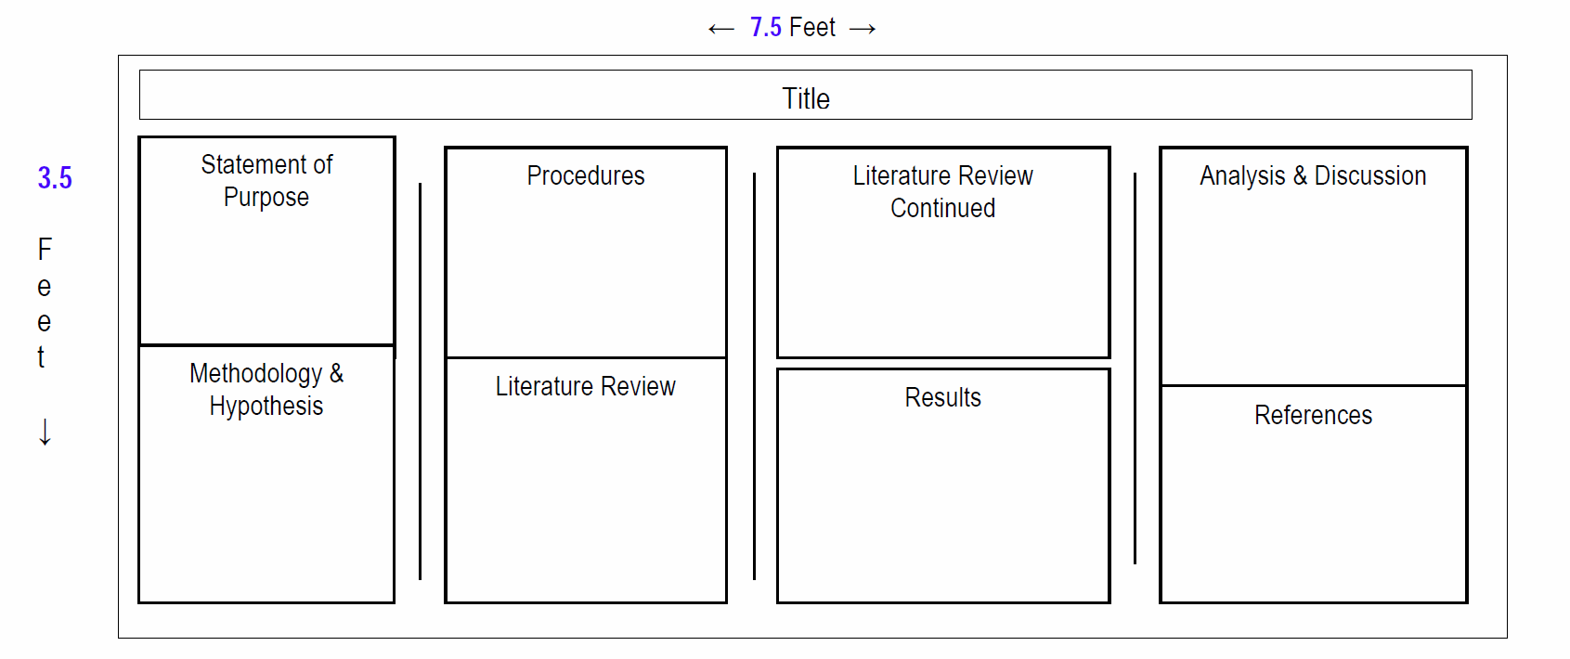
Key questions Poster Judges will consider:
Scientific Posters
1. Title (+1 point)
How well does the title capture the essence of the poster?
2. Statement of Purpose & Study Relevance (+8 points)
Is the purpose of the study concise and clearly stated? (3 pts)
Are the study measures well defined (i.e. what is the study examining)? (2 pts)
Does the review of the literature provide sufficient rationale for the study? (3 pts)
3. Methodology & Procedures (+12 points)
Is the population of the study’s interest well defined? (3 pts)
Is there a selection bias for patients in the study? Subjects were randomized (3 pts); Subjects were controlled via
matching (2 pts); The cohort was stratified (for example by age or diagnosis) (1 pt); Subjects were not controlled (0 pts)
Are the study methods clear and concise? (3 pts)
Is the statistical methodology well defined and appropriate? (3 pts)
4. Results (+10 points)
Is the data for the results clearly reported? (4 pts)
Is the statistical-data analysis clearly explained? (3 pts)
Do the tables and figures complement the statistical data properly? (3 pts)
5. Analysis & Discussion (+11 points)
Do the data support the conclusions made in this study? (4 pts)
Are the interpretations biased? (3 pts)
Are the discussion and conclusion of the study consistent with results, interpretation of the data, and answers the research question? (4 pts)
6. Overall Educational Value (+5 points)
Overall, does the poster exhibit provide meaningful education value? (2 pts)
Is the study novel and does it provide new data to the body of scientific literature? (2 pts)
Is a clear conclusion reported? (1 pt)
7. Aesthetics (+8 points)
Is the text free of grammatical and spelling errors? (5 pt)
Are the photos appropriate and do they visually complement the study? (1 pt)
Are all of the elements of the poster exhibit easy to follow? (Balance of design—layout, use of colors, lettering) (2 pts)
8. Commercialism (-10 points)
Is there any obvious product advertisement? If yes, take 10 points off the total score. 10

